Table 1
Physicochemical properties of CeO₂ NPs
Physicochemical properties |  | CeO₂ NPs
Primary shape (TEM image) |  | 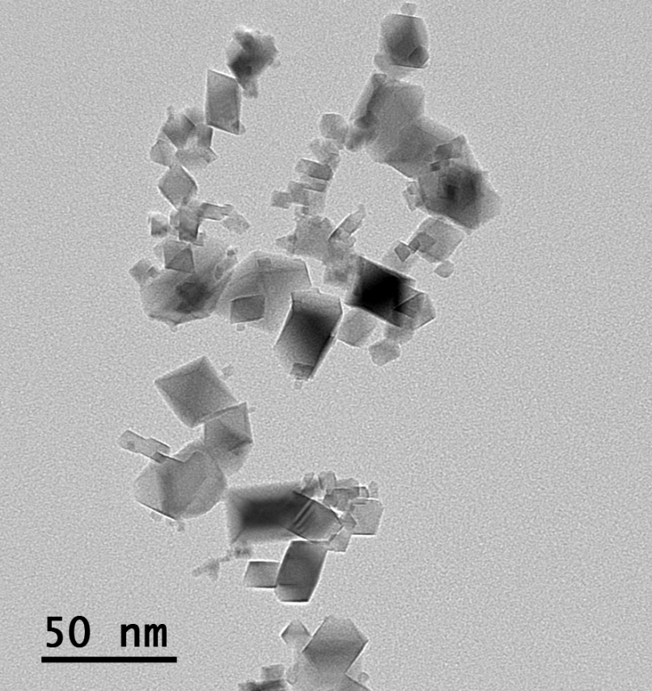
Primary size |  | 14.2 ± 5.03 nm
Purity |  | 100%
Hydrodynamic size |  | 76.3 nm
Zeta potential |  | 47.37 mV

